
RAMAIAH
Institute of Technology
USN | 1 | M | S

(Autonomous Institute, Affiliated to VTU)
(Approved by AICTE, New Delhi & Govt. of Karnataka) Accredited by NBA & NAAC with ‘A’ Grade

SUPPLEMENTARY SEMESTER EXAMINATIONS – AUGUST 2019

Course & Branch | : | B.E.: Information Science and Engineering | Semester | : | IV
Subject | : | Finite Automata and Formal Languages | Max. Marks | : | 100
Subject Code | : | IS416/IS46 | Duration | : | 3 Hrs

Instructions to the Candidates:
- Answer one full question from each unit.

 |  | UNIT- I
1. | a) | Construct a DFA which accepts strings of 0’s and 1’s, where the value of each string is represented as a binary number and only the strings which are divisible by two should be accepted. | CO1 | (09)
 | b) | Prove the statement: If D=(Q_{D},Σ,δ_{D},{q₀},F_{D}) is the DFA constructed from NFA N=(Q_{N},Σ,δ_{N},q₀,F_{N}) by the subset construction, then L(D)=L(N). | CO1 | (06)
 | c) | Explain how NFA is different from DFA. | CO1 | (05)
2 | a) | Explain any three applications of finite automata. | CO1 | (06)
 | b) | Convert the following NFA to its equivalent DFA by applying subset construction method: | CO1 | (10)
  δ | a | b
  →qo | {q0,q1} | {q0}
  q1 | Ø | {q2}
  *q2 | Ø | Ø
 | c) | Define with set notation the ‘Language of NFA’. | CO1 | (04)
 |  | UNIT– II
3. | a) | List down all the closure properties of regular languages. | CO2 | (04)
 | b) | Derive regular expression R₁₃⁽²⁾for the following FA:  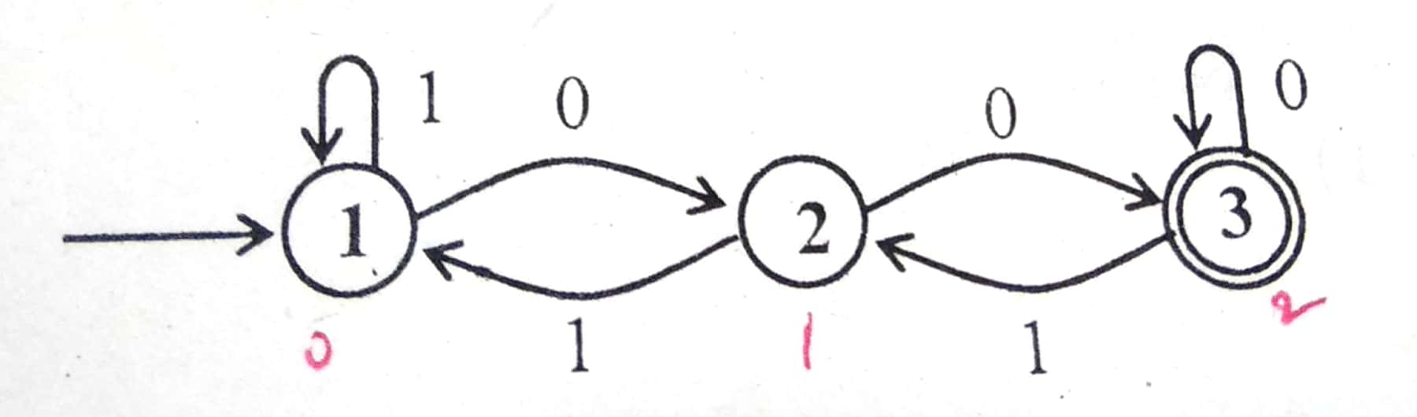 | CO2 | (08)
 | c) | Minimize the following DFA- | CO2 | (08)
  δ | a | b
  →q0 | q1 | q3
  q1 | q2 | q4
  q2 | q1 | q4
  q3 | q2 | q4
  *q4 | q4 | q4
4. | a) | Write the regular expression for the following languages:  - Strings of a’s and b’s with alternate a’ and b’s.  - Strings of 0’s and 1’s whose length is either even or multiples of three.  - L={a^{n}b^{m}| n>=4, m<=3} | CO2 | (06)
 | b) | Write general model of ε –NFA for the regular expressions R*. And recognize the regular expression defined by the following ε –NFA:  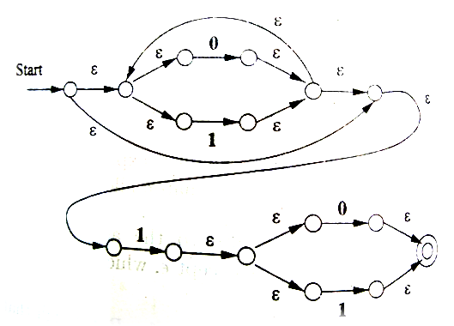 | CO2 | (04)
 | c) | Write pumping lemma theorem statement. And show that the language L={a^{n}b^{n}, n>=0}is non-regular. | CO2 | (06)
 | d) | Transform the following FA to accept language L^{R}. Let L is the language defined by the given FA.  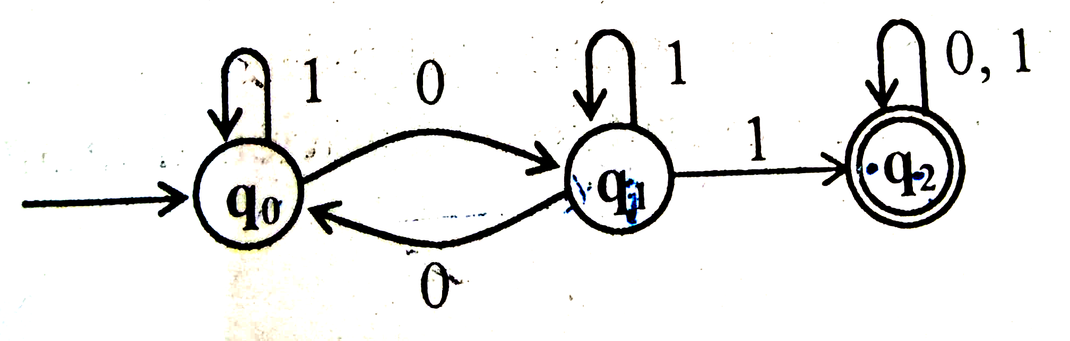 | CO2 | (04)
 |  | UNIT- III
5. | a) | With an example, explain Context free Language. Show that the following is ambiguous grammar for the expression (a+b) * (a-b)  E → E+E | E-E  E → E*E | E/E  E →(E) | I  I → a | b | c | CO3 | (10)
 | b) | Consider the following grammar:  S → ASB | AbBa  A →aAS | AaB | B  B →SbS | A | bb | Ɛ  - Eliminate Ɛ production.  - Eliminate any unit production in the resulting grammar.  - Eliminate any useless symbols in the resulting grammar.  - Put the grammar in Chomsky normal form. | CO3 | (10)
6. | a) | Design CFG for the following languages.  - L= {a^{n}b^{m} | n≥0, m>n}  - L= {a^{n}b^{n-3} | n≥3}  - L={w: |w| mod 3>0 where w ∈ {a}* }  - L= {0^{n}1^{n} | n ≥ 1}. | CO3 | (10)
 | b) | Define parse tree and yield of the parse tree. Obtain the leftmost and right most derivation for the string aaabbabbba given the grammar:  S → aB | aA  A → aS | bAA | a  B → bS | aBB | b | CO3 | (10)
 |  | UNIT- IV
7. | a) | Define the language of PDA, obtain a PDA to accept the language L(M) = { a^{n}b^{2n} |n>=1}. | CO4 | (10)
 | b) | Convert the following grammar into PDA. Detailed steps to be shown:  S → aA  A → aABC | bB | a  B → b  C → c | CO4 | (10)
8. | a) | Define PDA and obtain a PDA to accept the language  L= {ww^{R}|wϵ (a+b)*} by a final state, where w^{R} is reverse of w. | CO4 | (10)
 | b) | Define deterministic and non deterministic PDA. Give the procedure to convert PDA to CFG. | CO4 | (10)
 |  | UNIT- V
9. | a) | Define language of a turing machine. Prove that every language accepted by a multitape Turing machine is recursively enumerable. | CO5 | (10)
 | b) | Illustrate the halting problem in turing machine. Design Turing machine to accept the language L= {0^{n}1^{n}2^{n} | n≥1}. | CO5 | (10)
10. | a) | With the help of example, discuss the move (ID) of a turing machine. Prove that if M_{N} is a nondeterministic turing machine, then there is a deterministic TM M_{D} such that L(M_{N})=L(M_{D}). | CO5 | (10)
 | b) | List out the different programming techniques for Turing machine. With the help of example, discuss any two. | CO5 | (10)

****************

